ICIS AIR Dataflow Configuration Guide

# Setup Your Virtual Exchange Service (VES)

The first step is to create your own Virtual Exchange Service (VES), formerly Virtual Node, if you don’t have one. To be an owner of a VES, you must have an administrator’s account in NAAS, please contact node helpdesk at [nodehelpdesk@epacdx.net](mailto:nodehelpdesk@epacdx.net) to establish a node administrator account. VES creation is fairly straightforward:

1. For VES in PRODUCTION environment, go to <https://vnap.cloudapp.net>; for VES in TEST environment, go to <https://vnaptest.epacdxnode.net> .
2. Choose Create Node on the left panel, and enter your node information in the form.

Please refer to the Virtual Exchange Service Administrator’s Guide for additional information.

# Import ICIS-AIR Dataflow

Virtual Exchange Service has a set of prebuilt services for ICIS-AIR in a node called SHARE. The quickest way is to import all the services into your node. This is done by click on the **Import Configurations** link in the left panel. The following form should be displayed:

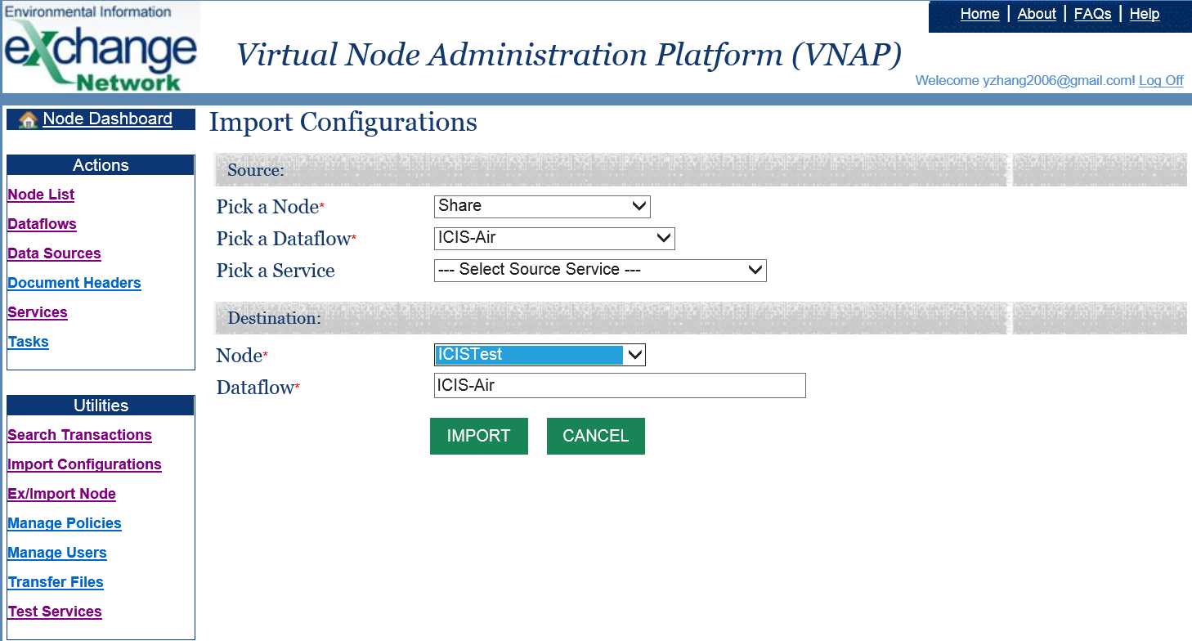

In the **source** of the Import, select the **Share** node and pick the **ICIS-AIR** dataflow. In the Destination, choose your node name. Click on the IMPORT button when done. All the ICIS-AIR services will be imported into your node.

There are three types of services in each data family in ICIS-AIR:

* **Query Services**: These are the services responsible for retrieving data from the staging tables, and constructing XML instance documents.
* **Execute Services**: These are the services for ICIS-AIR submissions to CDX. You can submit individual data family or using the multi-payload service to submit multiple data families in one package.
* **Delete Services**: These are the special Execute Services that perform data deletion in ICIS-AIR. In other words, they send ICIS records to be deleted by the backend system.

# Configure Data Source

One entity that is not imported from the **Share** node is the Data Source, which contains the database server and login account information. Data Source must be specified before executing any services. This is done by clicking on the **Data Source** link in the left panel and then click on the **Add New** button on the web page. A Data Source form will be displayed:

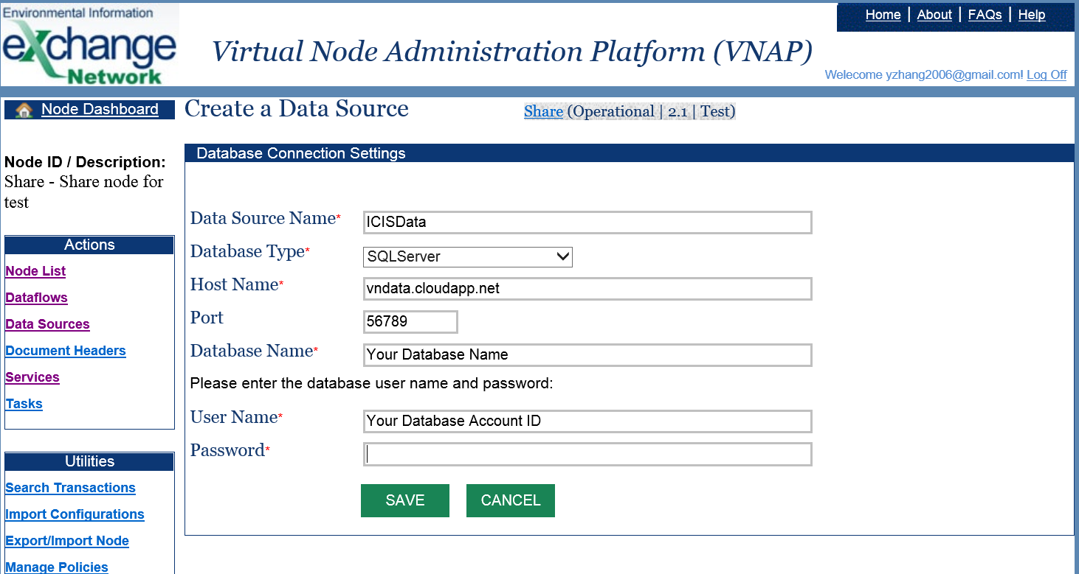

On this form:

1. Type in **ICISData** in the Data Source Name. You may use other names, but if you do, please change all query services to match your data source name.
2. Select **SQLServer** as the database type if you use the staging tables provided by the VES.
3. Enter the Host Name of the database server. If the hosted Azure database is used, the host name is **vndata.cloudapp.net**; if you use the Virtual Exchange Service Connector to connect to database in your environment, enter **localhost** as the Host Name.
4. Enter the port number of the database server. You will have a special port number if the Virtual Exchange Service Connector is used. Please contact [yzhang2006@gmail.com](mailto:yzhang2006@gmail.com) if you don’t know your port number.
5. Enter the Database Name. For SQL server, this is the ICIS-AIR database name; For ORACLE server with Virtual Exchange Service Connector, this should be the CID (Oracle System ID) suffixed with the network domain name. For instance, if your CID is dstore and domain is example.com, then the Database Name should be **dstore.example.com**.
6. Type in your User Name and Password. This is the account for accessing the ICIS-AIR database.

Click the SAVE button when done. The VES will attempt to make a database connection and display error message if failed. The data source information will not be saved unless all information is valid.

# Add ICIS-AIR Headers

A document header is required in ICIS-AIR submissions and it contains user account information for backend authentication and data loading. You should add a header to the ICIS-AIR dataflow before submitting data to CDX. As shown below, the Application User ID field should contain your ICIS ID and it will be inserted into the document header during submission.

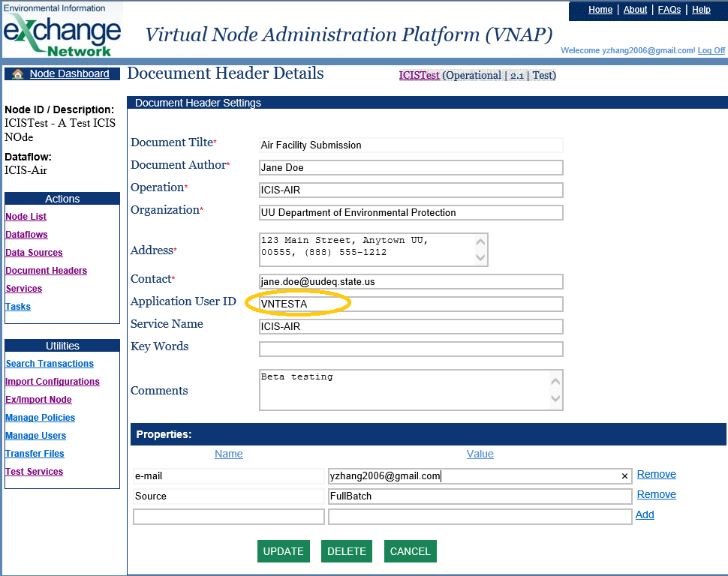

# ICIS-Air Test Submissions

You may test data submissions to ICIS-AIR using the Test Service link in the left panel as shown in the following screen:

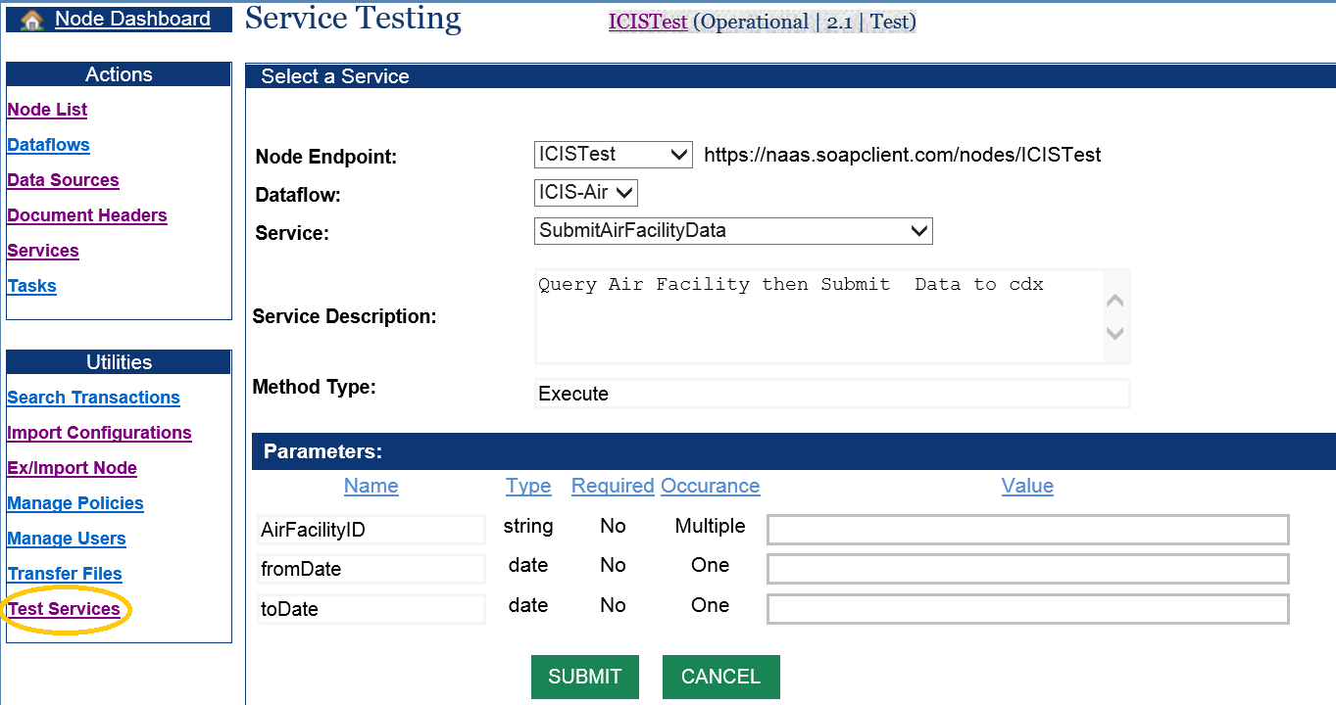

On this form:

1. Select the node that contains ICIS-AIR dataflow from the dropdown list.
2. Pick the ICIS-AIR as the dataflow.
3. Select one of the “Submit” services from the service list.
4. Click the Submit button to deliver the document to CDX node.

# Check Transaction Status

Once submitted, you can check transaction status after about 15+ minutes. There should be some ICIS-AIR backend reports available if all went well.

Click on **Search Transactions** link from the left panel. The transaction search page will appear (see below). On this page, select the name of your node, and the ICIS-AIR as the dataflow. A list of ICIS-AIR transactions will be displayed as shown in the screenshot below. Additional information of a particular transaction is available by clicking on the Transaction ID.

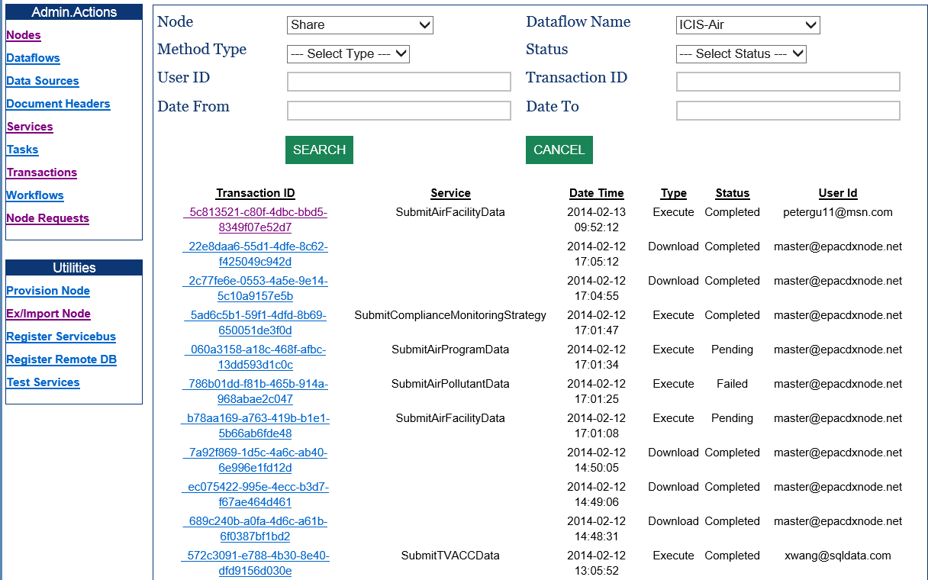

# View ICIS Transaction Status and Reports

Document processing is an asynchronous process in CDX and ICIS. It may take somewhere from 15 minutes up to an hour before the transaction is finalized and backend reports are available. When a transaction is completed, the transaction detail page, as shown below, contains status detail and batch processing reports that can be downloaded from the VES. You should pay special attention to the Rejected report file in the zipped document as those records need to be revised for the next submission.

